**Week-2**

**Problem-1**

Create a Feedback form using HTML (With Internal CSS), it should contain

-> Name (optional)

-> Email(Optional)

-> phone (optional)

-> Rating

-> Any Questions regarding product or service.

-> Additional comments (optional)

-> Submit button

Note: once you create web page upload the page to Github account with public access

<!DOCTYPE html>

<html lang="en">

<head>

<meta charset="UTF-8">

<meta name="viewport" content="width=device-width, initial-scale=1.0">

<title>Feedback Form</title>

<style>

body {

font-family: Arial, sans-serif;

background-color: #f4f4f4;

margin: 0;

padding: 20px;

}

.container {

max-width: 500px;

background: white;

padding: 20px;

border-radius: 8px;

box-shadow: 0 0 10px rgba(0, 0, 0, 0.1);

margin: auto;

}

h2 {

text-align: center;

color: #333;

}

label {

font-weight: bold;

display: block;

margin: 10px 0 5px;

}

input, textarea, select {

width: 100%;

padding: 8px;

margin-bottom: 10px;

border: 1px solid #ccc;

border-radius: 4px;

}

button {

width: 100%;

padding: 10px;

background: #d73aa8;

color: white;

border: none;

border-radius: 4px;

cursor: pointer;

font-size: 16px;

}

button:hover {

background: #da9cc7;

}

</style>

</head>

<body>

<div class="container">

<h2>Feedback Form</h2>

<form action="#" method="post">

<label for="name">Name (Optional):</label>

<input type="text" id="name" name="name" placeholder="Enter your name">

<label for="email">Email (Optional):</label>

<input type="email" id="email" name="email" placeholder="Enter your email">

<label for="phone">Phone (Optional):</label>

<input type="tel" id="phone" name="phone" placeholder="Enter your phone number">

<label for="rating">Rating:</label>

<select id="rating" name="rating" required>

<option value="">Select Rating</option>

<option value="5">⭐⭐⭐⭐⭐ (Excellent)</option>

<option value="4">⭐⭐⭐⭐ (Good)</option>

<option value="3">⭐⭐⭐ (Average)</option>

<option value="2">⭐⭐ (Poor)</option>

<option value="1">⭐ (Very Bad)</option>

</select>

<label for="questions">Any Questions regarding product or service:</label>

<textarea id="questions" name="questions" rows="3" placeholder="Write your queries here..."></textarea>

<label for="comments">Additional Comments (Optional):</label>

<textarea id="comments" name="comments" rows="3" placeholder="Write any additional feedback..."></textarea>

<button type="submit">Submit Feedback</button>

</form>

</div>

</body>

</html>

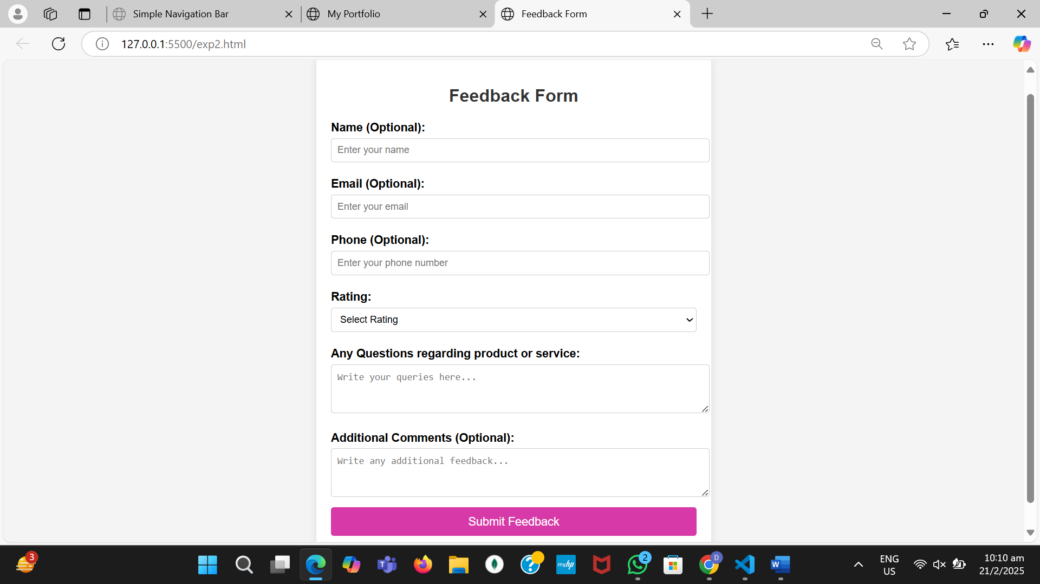

**Problem-2**

update a Portfolio page using internal CSS , it should contain

-> Self introduction

-> skills

-> projects/work experiences (Git links)

-> Feedback /achievements

-> Education profile

-> Contact information.(Social media /phone /email)

Note: add Internal CSS

Note: once you update the portfolio page upload the page with necessary documents to Github account with public access

and submit that github link here :

<!DOCTYPE html>

<html lang="en">

<head>

<meta charset="UTF-8" />

<meta name="viewport" content="width=device-width, initial-scale=1.0" />

<title>My Portfolio</title>

<style>

body {

font-family: "Arial", sans-serif;

background-color: rgb(227, 158, 192); */* Teal Background */*

color: #fbffe4; */* Light Cream Text */*

margin: 0;

padding: 0;

}

header {

background-color:lightyellow ; */* Light Teal */*

padding: 20px;

text-align: center;

color: #3d8d7a; */* Teal Text */*

}

header h1 {

font-size: 3em;

margin: 0;

text-decoration: underline; */* Underlines the text */*

}

header p {

font-size: 1.5em;

margin: 0;

}

section {

padding: 40px;

margin: 20px 10%;

background-color: #fbffe4; */* Light Cream */*

border-radius: 8px;

color: #3d8d7a; */* Teal Text */*

}

h2 {

font-size: 2em;

color: #3d8d7a; */* Teal */*

margin-bottom: 20px;

}

ul {

list-style-type: none;

padding: 0;

}

li {

margin-bottom: 15px;

}

a {

color: #a3d1c6; */* Light Teal */*

text-decoration: none;

}

a:hover {

text-decoration: underline;

}

p {

font-size: 1.2em;

}

.contact a {

display: block;

margin: 10px 0;

font-size: 1.2em;

color: #3d8d7a; */* Teal */*

}

.contact a:hover {

text-decoration: underline;

}

footer {

background-color:lightyellow; */* Light Teal */*

text-align: center;

padding: 20px;

margin-top: 30px;

color: #3d8d7a; */* Teal Text */*

}

</style>

</head>

<body>

<header>

<h1><strong>MY PORTFOLIO</strong></h1>

<h2><strong>Divya</strong></h2>

<p><strong>Aspiring Developer</strong></p>

</header>

<section id="introduction">

<h2><strong><u>About Me</u></strong></h2>

<p>

Hello! I am <strong>Divya</strong>, a passionate developer with a keen

interest in web development, programming, and technology. I thrive on

solving real-world problems and am always exploring new technologies to

broaden my skill set.

</p>

</section>

<section id="skills">

<h2><strong><u>Skills</u></strong></h2>

<ul>

<li>

<strong>Languages:</strong> HTML, CSS, JavaScript, Java, C++, Python

</li>

<li>

<strong>Frameworks & Libraries:</strong> React, Node.js, MongoDB

</li>

<li><strong>Database Management:</strong> SQL, DBMS</li>

<li><strong>Tools:</strong> Git, Docker, AWS, GenAI</li>

</ul>

</section>

<section id="projects">

<h2><strong><u>Projects & Work Experience</u></strong></h2>

<ul>

<li>

<a

href="#"

target="_blank"

><strong>Food Tracking App</strong></a

>

- A web-based platform to avoid hassle queires and get real tracking.

</li>

<li>

<a

href="#"

target="_blank"

><strong>Another Project</strong></a

>

- A brief description of another project.

</li>

</ul>

</section>

<section id="feedback">

<h2><strong><u>Achievements</u> </strong></h2>

<p>

Have complete projects based on e-commerce website.

</p>

<p>

<strong>🎓 Academic Excellence</strong> - Awarded for top performance in

the Computer Science Department.

</p>

</section>

<section id="education">

<h2><strong><u>Education</u></strong></h2>

<p><strong>B.Tech in Computer Science:</strong> KMIT (Keshav Memorial Institute of Technology), 2022-2026</p>

<p><strong>Intermediate:</strong> Narayana Junior College, 2020-2022</p>

<p><strong>School:</strong> Slate-The-School, 2010-2020</p>

</section>

<section id="contact" class="contact">

<h2><strong>Contact</strong></h2>

<p><strong>Email:</strong> divyakanaparti@gmail.com</p>

<p><strong>Phone:</strong> +91 xxxxxxxxxx</p>

<a href="#" target="_blank"

><strong>GitHub Profile</strong></a

>

</section>

<footer>

<p>&copy; 2025 | All Rights Reserved</p>

</footer>

</body>

</html>

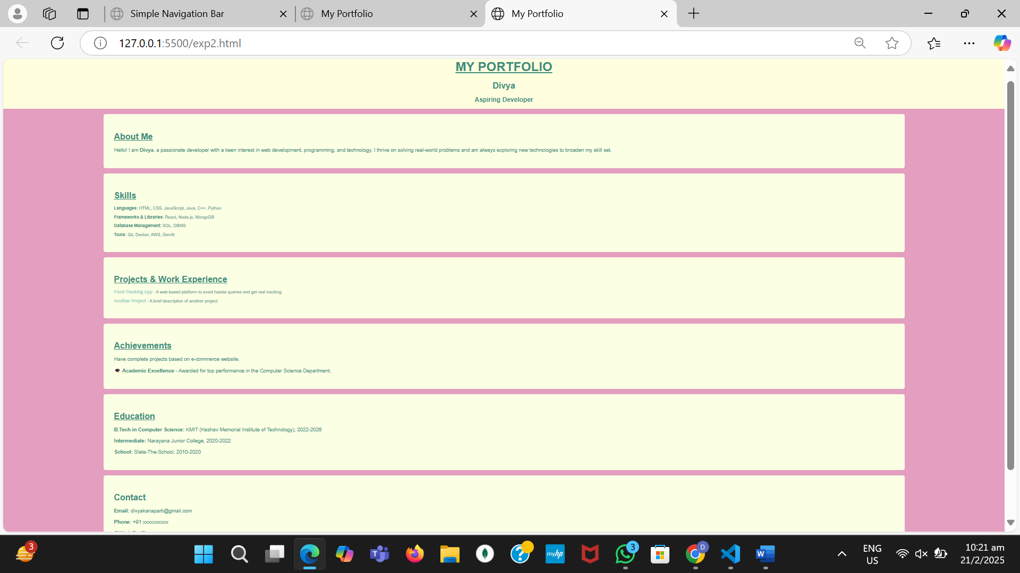

**Problem-3**

Update the both (feedback and portfolio) pages with external css.

Note: once you update the poftfolio and Feedback pages upload the page with neccesary document to Github account with public access

and submit that github link here :

Feedback.html

<!DOCTYPE html>

<html lang="en">

<head>

<meta charset="UTF-8">

<meta name="viewport" content="width=device-width, initial-scale=1.0">

<title>Feedback Form</title>

<link rel="stylesheet" href="feedback.css"> *<!-- Link to external CSS -->*

</head>

<body>

<div class="container">

<h2>Feedback Form</h2>

<form action="#" method="post">

<label for="name">Name (Optional):</label>

<input type="text" id="name" name="name" placeholder="Enter your name">

<label for="email">Email (Optional):</label>

<input type="email" id="email" name="email" placeholder="Enter your email">

<label for="phone">Phone (Optional):</label>

<input type="tel" id="phone" name="phone" placeholder="Enter your phone number">

<label for="rating">Rating:</label>

<select id="rating" name="rating" required>

<option value="">Select Rating</option>

<option value="5">⭐⭐⭐⭐⭐ (Excellent)</option>

<option value="4">⭐⭐⭐⭐ (Good)</option>

<option value="3">⭐⭐⭐ (Average)</option>

<option value="2">⭐⭐ (Poor)</option>

<option value="1">⭐ (Very Bad)</option>

</select>

<label for="questions">Any Questions regarding product or service:</label>

<textarea id="questions" name="questions" rows="3" placeholder="Write your queries here..."></textarea>

<label for="comments">Additional Comments (Optional):</label>

<textarea id="comments" name="comments" rows="3" placeholder="Write any additional feedback..."></textarea>

<button type="submit">Submit Feedback</button>

</form>

</div>

</body>

</html>

Feedback.css

body {

font-family: Arial, sans-serif;

background-color: #f4f4f4;

margin: 0;

padding: 20px;

}

.container {

max-width: 500px;

background: white;

padding: 20px;

border-radius: 8px;

box-shadow: 0 0 10px rgba(0, 0, 0, 0.1);

margin: auto;

}

h2 {

text-align: center;

color: #333;

}

label {

font-weight: bold;

display: block;

margin: 10px 0 5px;

}

input, textarea, select {

width: 100%;

padding: 8px;

margin-bottom: 10px;

border: 1px solid #ccc;

border-radius: 4px;

}

button {

width: 100%;

padding: 10px;

background: #d73aa8;

color: white;

border: none;

border-radius: 4px;

cursor: pointer;

font-size: 16px;

}

button:hover {

background: #da9cc7;

}

**OUTPUT:**

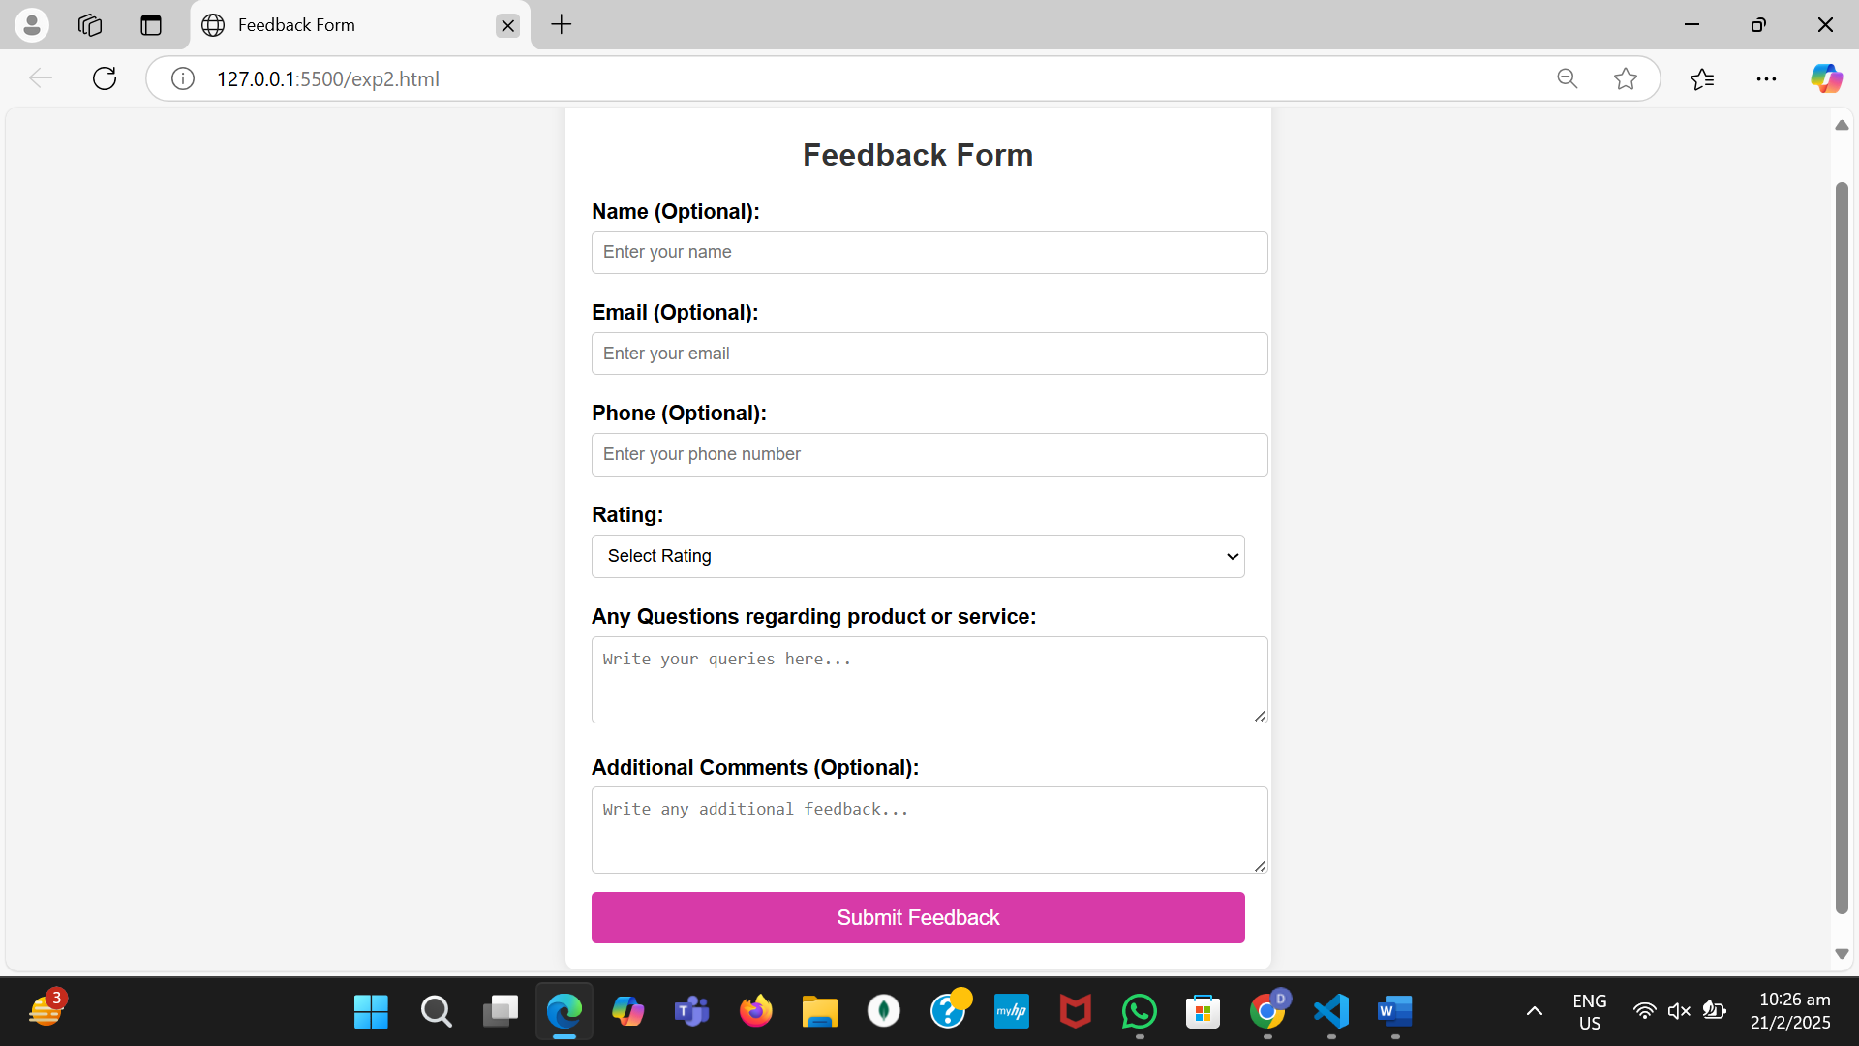

**portfolio.html**

**<!DOCTYPE html>**

**<html lang="en">**

**<head>**

**<meta charset="UTF-8" />**

**<meta name="viewport" content="width=device-width, initial-scale=1.0" />**

**<title>My Portfolio</title>**

**<link rel="stylesheet" href="style.css">**

**</head>**

**<body>**

**<header>**

**<h1><strong>MY PORTFOLIO</strong></h1>**

**<h2><strong>Divya</strong></h2>**

**<p><strong>Aspiring Developer</strong></p>**

**</header>**

**<section id="introduction">**

**<h2><strong><u>About Me</u></strong></h2>**

**<p>**

**Hello! I am <strong>Divya</strong>, a passionate developer with a keen**

**interest in web development, programming, and technology. I thrive on**

**solving real-world problems and am always exploring new technologies to**

**broaden my skill set.**

**</p>**

**</section>**

**<section id="skills">**

**<h2><strong><u>Skills</u></strong></h2>**

**<ul>**

**<li>**

**<strong>Languages:</strong> HTML, CSS, JavaScript, Java, C++, Python**

**</li>**

**<li>**

**<strong>Frameworks & Libraries:</strong> React, Node.js, MongoDB**

**</li>**

**<li><strong>Database Management:</strong> SQL, DBMS</li>**

**<li><strong>Tools:</strong> Git, Docker, AWS, GenAI</li>**

**</ul>**

**</section>**

**<section id="projects">**

**<h2><strong><u>Projects & Work Experience</u></strong></h2>**

**<ul>**

**<li>**

**<a**

**href="#"**

**target="_blank"**

**><strong>Food Tracking App</strong></a**

**>**

**- A web-based platform to avoid hassle queires and get real tracking.**

**</li>**

**<li>**

**<a**

**href="#"**

**target="_blank"**

**><strong>Another Project</strong></a**

**>**

**- A brief description of another project.**

**</li>**

**</ul>**

**</section>**

**<section id="feedback">**

**<h2><strong><u>Achievements</u> </strong></h2>**

**<p>**

**Have complete projects based on e-commerce website.**

**</p>**

**<p>**

**<strong>🎓 Academic Excellence</strong> - Awarded for top performance in**

**the Computer Science Department.**

**</p>**

**</section>**

**<section id="education">**

**<h2><strong><u>Education</u></strong></h2>**

**<p><strong>B.Tech in Computer Science:</strong> KMIT (Keshav Memorial Institute of Technology), 2022-2026</p>**

**<p><strong>Intermediate:</strong> Narayana Junior College, 2020-2022</p>**

**<p><strong>School:</strong> Slate-The-School, 2010-2020</p>**

**</section>**

**<section id="contact" class="contact">**

**<h2><strong>Contact</strong></h2>**

**<p><strong>Email:</strong> divyakanaparti@gmail.com</p>**

**<p><strong>Phone:</strong> +91 xxxxxxxxxx</p>**

**<a href="#" target="_blank"**

**><strong>GitHub Profile</strong></a**

**>**

**</section>**

**<footer>**

**<p>&copy; 2025 | All Rights Reserved</p>**

**</footer>**

**</body>**

**</html>**